*SQLMurderMystery*

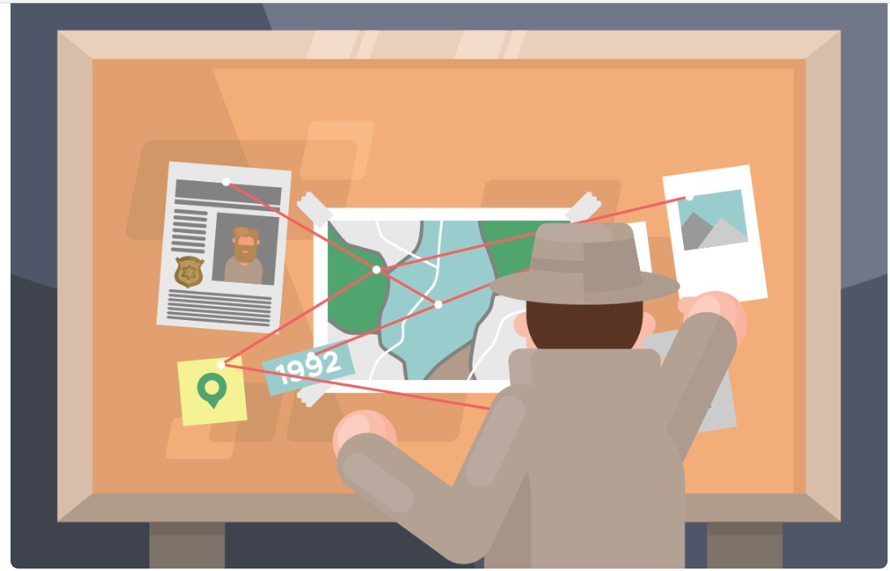

A crime has taken place and the detective needs your help. The detective gave you the crime scene report, but you somehow lost it. You vaguely remember that the crime was a **murder** that occurred sometime on **Jan.15,** **2018** and that it took place in **SQL** **City**.Start by retrieving the corresponding crime scene report from the police department’s database.

Schema Diagram:

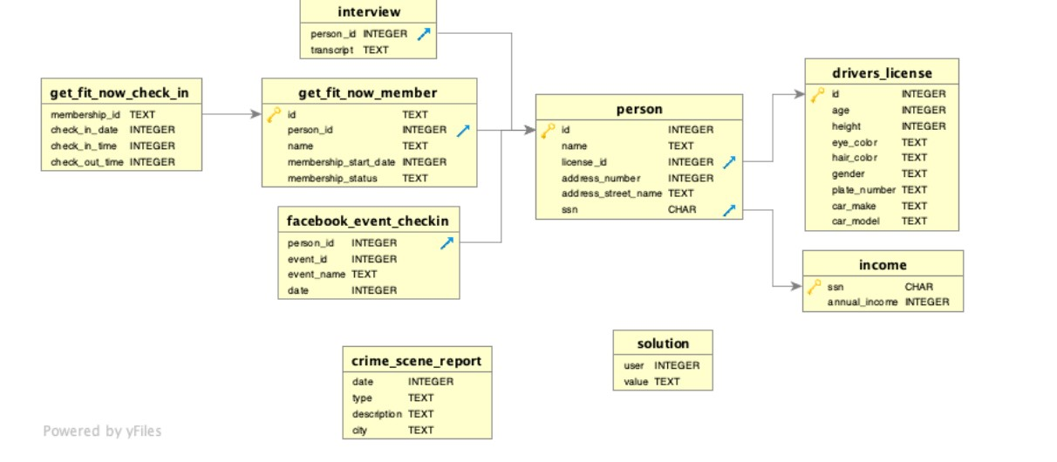

**Objective:**

Retrieve the crime scene report for a murder that occurred on January 15, 2018, in SQL City.

**SQL Query:**

Select * from crime_scene_report where date=20180115 AND City='SQL

City'

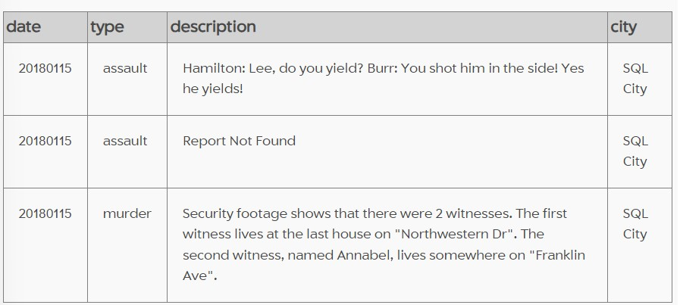

To further investigate the murder incident, you may want to gather more details from the crime scene report. In your case, the relevant information is in the row where the type is 'murder.' Let's break down the information provided:

Security footage shows that there were 2 witnesses. The first witness lives at the last house on "Northwestern Dr". The second witness, named Annabel, lives somewhere on "Franklin Ave".

**There are Two witnesses.**

**1. "Northwestern Dr" Last house**

Extract data from person table

SELECT * FROM person WHERE address_street_name = 'Northwestern

Dr' ORDER BY address_number DESC LIMIT 1;

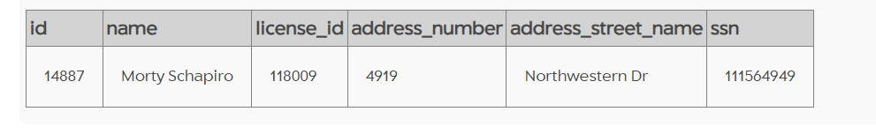

**2.Named Annabel, lives somewhere on "Franklin Ave".**

SELECT * FROM person WHERE address_street_name LIKE "Franklin

Ave%" and name like 'Annabel%'

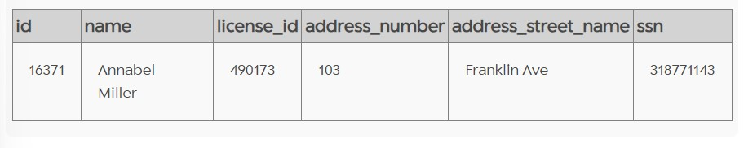

Now using person_id extract information from interview table **Morty Schapiro's Account (ID: 14887):**

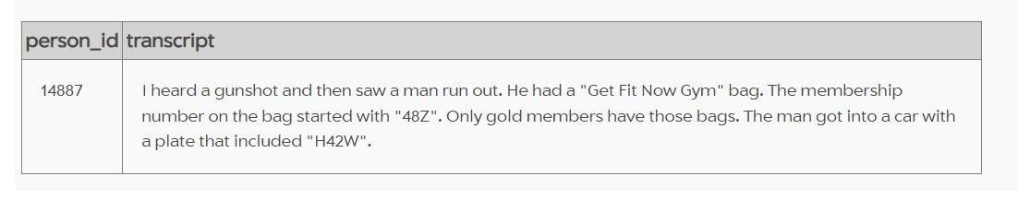

**Annabel's Account (ID: 16371):**

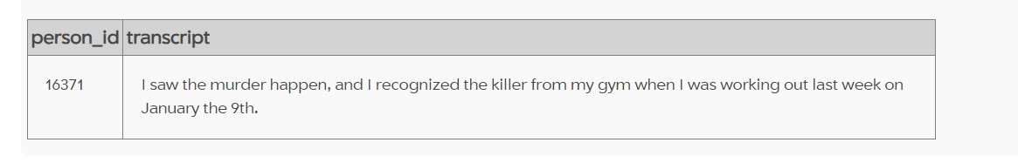

Select *from get_fit_now_check_in join get_fit_now_member on get_fit_now_check_in.membership_id=get_fit_now_member.id where membership_id like '48Z%' and membership_status='gold'

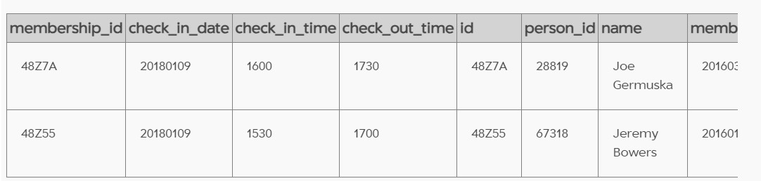

# TheMurdered

JeremyBowers

Select *from interview where person_id=67318

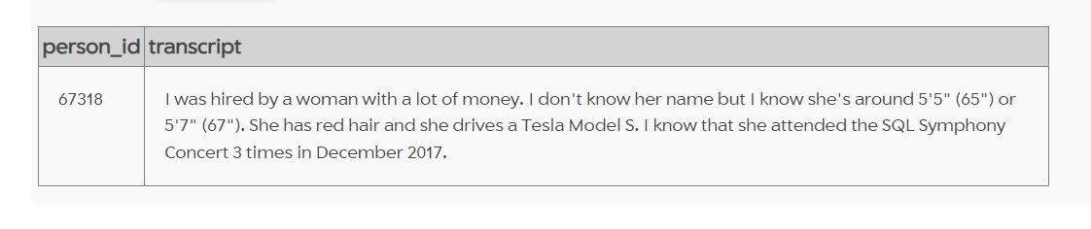

Select *from person join drivers_license on person.license_id=drivers_license.id where gender ='female' and hair_color ='red' and height between 65 and 67 and car_make='Tesla' and car_model='Model S'

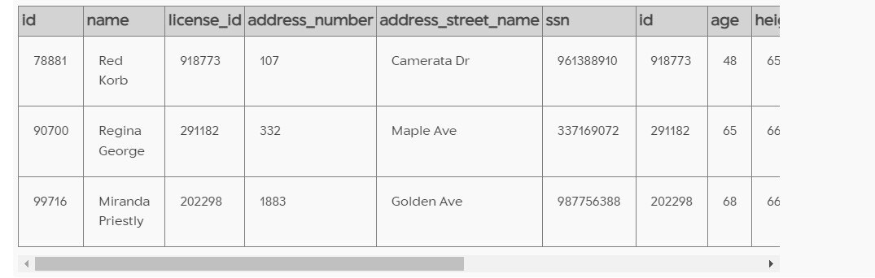

Select * from income where ssn in (961388910,337169072,987756388)

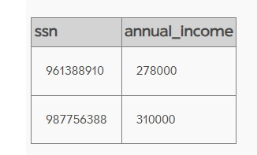

AS they mentioned high income therefore mastermind of the truth is

Select * from person where ssn=987756388

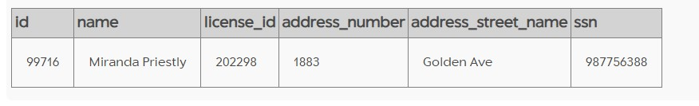

**Mastermind of the True Crime**

**Miranda Priestly**

**-The Murder Mystery Solved By Ishaan**